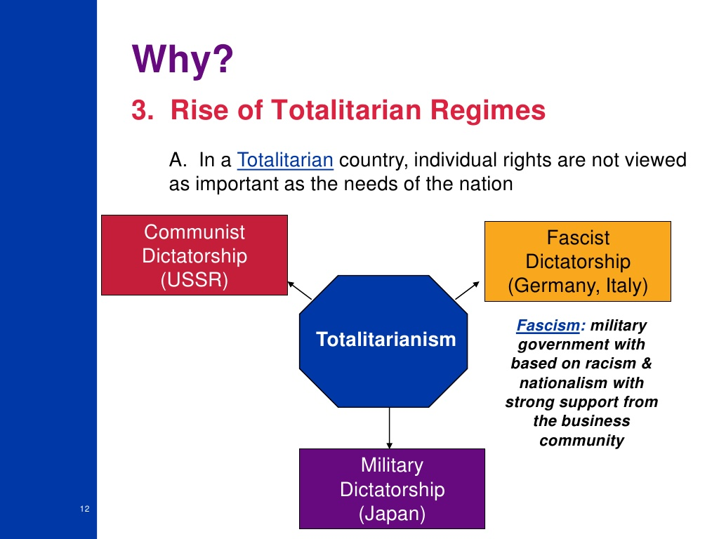
UNITED STATES HISTORY LECTURE NOTES PRE-USA ENTRY World War 2
There were 5 major causes for WW 2
1-economic instability caused by world wide 1929 economic depression
2-Rise of Dictatorships in Italy, Germany, Japan, Spain and USSR in 1920s/1930s
3-League of Nations not powerful enough to stop Dictators
4-Dictators wanted to control certain world regions and dominate world
5-MOST IMPORTANT–problems left over from Treaty of Versailles and WW1
6-USA foreign policy of Isolationism in 1920s/1930s

In 1931 the Japanese military took control of the nation. In Italy, Mussolini took control by 1922. In Germany Hitler seized control in 1933. All three were Totalitarian govts, which means complete control of a nation and its economy by one leader or small group. Dictators are associated with Totalitarian govts. In 1917 Lenin took control and the Russia/USSR and it became communist (until 1993). Spain became Fascist in early 1930s.

5 characteristics of Totalitarianism;
1-complete control of economy, govt and military by 1 person
2-very strong leader/dictator
3-very large and powerful military
4-freedoms/rights not extended to citizens
5-nation seeks to extend/expand borders (take over other nations)

1935-1939 Germany restricted Jewish life by invoking Nuremberg Laws. Stated Jews could not own property, vote and lost all civil rights in Germany. These restrictions led to the “Final Solution”, where 6m Jews died in Concentration Camps(and 6m others). 1935-36 Germany began a secret build up of its military in violation of Treaty of Versailles. 1935 Mussolini invaded Ethiopia and by 1936 controlled it. 1936 Germany sent troops to the Rhineland and occupied the once German region. 1936 Summer Olympics were held in Berlin, Germany. Jesse Owens, African-American, won 4 Gold Medals and destroyed the myth of the superiority of the Aryan race. 1936-1939 Spanish Civil War took place between communist supported Franco and Loyalists (loyal to king). Franco and communists won Spanish Civil War. USSR, Italy and Germany supported Communists/Franco. USA supported Loyalists. 1931 Japan invaded Manchuria and began an aggressive policy of Imperialism toward China. 1937 Japan attacked China at Marco Polo Bridge. USA supported China by sending military equipment. League of Nations was too weak to stop the military actions of Germany, Italy or Japan. Oct 1937 FDR gave a speech and coined the term “Collective Security” which meant Democratic nations should join together and isolate warring nations. FDR wanted to solve problems before the situation escalated in a military conflict. March 1938 Hitler annexed Austria without firing a shot. Spring 1938 Hitler took over the Sudetenland, a region of Czechoslovakia with a German population. September 1938 England’s Prime Minister Neville Chamberlin met with Hitler at the Munich Conference to settle the issue of the Sudetenland. The Munich Pact was signed. Hitler promised not to take over any more territory. Before the ink was dry on the Munich Pact Hitler was working on a plan to take over all of Czechoslovakia. March 1939 Hitler took over all of Czechoslovakia. At dawn on Sept 1, 1939 Germany’s army invaded Poland. The “blitzkrieg” (lighting war) shocked the world. England and France declared war on Germany on Sept 3, 1939. It took 3 weeks for Germany to take over Poland.
USA passed Neutrality Acts in 1935, Feb 1936, May 1937 Nov 1939. Each (USA) Neutrality Act demonstrated the USA’s attempt to remain neutral yet at the same time assist the Allied Powers (England and Free France). By start of 1941 the USA would be
“The Arsenal of Democracy” and supplied large amounts of military equipment/supplies to England prior to the USA entering the WW 2 in Dec 1941. April 9, 1940 Germany takes over Denmark, Norway by the end of May 1940 and The Netherlands, Belgium and Luxembourg. France surrenders on June 22, 1940. Free France was established by Charles deGaulle as an opposition govt to the German controlled French govt. May 1940 330,000 France and English soldiers are trapped at Dunkirk, France and are ferried across the English Channel to safety in England as Germany’s army is about to capture them. Germany begins a series of air strikes/raids/bombings against England, lasting early summer 1940 to end of October 1940. One of the most important technological advancements of 1940s was radar. Radar determined the location of a plane. The German air attacks to force England to surrender failed. Winston Churchill said, “Never in the field of human conflict was so much owed by so many to so few.”
June 1940 USA gave 500,000 rifles and 80,000 machine guns to England. Sept 1940 Destroyer Deal stated the USA would give England 50 WW1 destroyers in exchange for fishing rights. 1940 Presidential election FDR won 3rd term, which was the 1st time a person elected President 3 times. March 1941 USA authorized “Lend-Lease Act”, which stated any nation could lend/lease USA military equipment and/or to any nation “whose defense was vital to the USA”. This was America’s way of supporting the Allies in “an economic declaration of war” without actually declaring war against the Axis . Atlantic Charter signed in 1941 and was fore-runner of United Nations. June 1941 Germany attacked its one time ally, USSR, and the Germany army began to march into USSR. Germany and Soviet Union would fight numerous battles 1941-1944 until the Russian army slowly pushed back the German army out by 1944. In April, May, Sept, and Oct 1941 German U-boats attacked US ships. In July 1941 Japan takes over the present-day nations of Vietnam, Laos, and Cambodia, known as Indochina. USA placed an oil embargo against Japan. Japan needs oil to continue its military advances and devised a secret plan to attack USA Naval Fleet at Pearl Harbor in Dec 1941. USA quickly recovered from the GD because big business/industry began to manufacture millions of various military equipment/supplies. The US govt paid billions of dollars to US companies to produce war supplies. In 4 years USA built 55,000 tanks.

UNITED STATES HISTORY STUDY SHEET 1 WORLD WAR 2

1.Define the USA’s “cash and carry” policy (Oct 1939)
2. What did the 1939 Neutrality Act state
3. Name the 3 Axis Powers of WW2
4. What did USA do in June 1940 in regard to assisting England
4a. What did USA do in Sept 1940 in regard to assisting England
5. What was the Selective Training and Service Act
5a. What ages of American men were required to register
6. Who won the 1940 Presidential election
7. Why was FDR’s election significant
8. Define “Arsenal of Democracy
9. In March 1941 the USA passed the Lend-Lease Plan—explain it
10. Why was it difficult to impossible for the USA to ship needed war supplies to England
17. What is Pearl Harbor
18. List the date Pearl Harbor was attacked and by what nation
19. What time of day and what weekday was PH attacked
20. List the number of USA sailors/soldiers killed at PH attack
21.How many USA ships were destroyed/sunk and how many damaged at PH
22.How many USA planes were destroyed and how many damaged at PH
23.What did Pres FDR say (write quote) on Dec 8, 1941 about the attack at PH
24.What were the 3 major reasons the USA entered WW2

25.What role did African-Americans play in WW2

26.How many Japanese-Americans served in the USA military

27.How many Native-Americans served in the USA military

29.Rosie the Riveter (look up in another book)

30.Who was A. Phillip Randolph and is role during WW2 566

31.What was the Manhattan Project 567 and 583

34.574 What was D-Day

35.Where did the invasion take place (nation/location)

36.What was the importance of D-Day

37.List the month/day/year of D-Day

38.What was the code name for D-Day

38a. What USA General devised the D-Day plan

39. What is V-E Day and list date

40.When did FDR did and who became President 577

41. Who was USA General in the Pacific War 579

43. Define island hopping and leap frogging

46. 584 Name 2 Japanese cities bombed by USA on Aug 6 and 9, 1945

47. What reason did the US give for the bombing of the 2 cities

48. List the number of people killed at each Japanese city

49. What is V-J Day and list day

50. Explain the Internment of 112,000 Japanese-Americans during WW2 and why

UNITED STATES HISTORY WORLD WAR 2

Totalitarian govt means a _______________ or small group had complete and absolute ________ over all aspects of a nation. ___________ have no civil and political rights. The major reasons for the rise of Totalitarian govts/leaders after WW1 (1914-1918) to the start of WW2 in 1939 were a worldwide economic ___________ and because of the harsh ___________ of the Treaty of Versailles. Germany and AH refused to _________ the Treaty of Versailles and The _______of __________ was ineffective in stopping the _______ of Dictators during the ____________.The 3 Axis Powers of WW2 were ____________ , ____________ , and ______________. They attacked various nations and took control of them. They used ___________ military power to control these nations. AH controlled most of West ____________ by 1941. ________ controlled Manchuria by 1938 and in 1936 Italy controlled Ethiopia.

After WW1 many European nations became _______________ but prior and during WW2 some
of these nations came under the __________ of totalitarian leaders. Also some were taken over
by Germany and the USSR after _________.

From 1936 to 1941 ____________ arrested millions of Jewish people, put them in Concentration
Camps, and eventually executed _____ million Jews. This is known as The ____________ or The Final Solution. Most of the Jewish population lived in Germany and Poland.

Between 1935-1939 USA govt passed 4 ____________ _______ because of anti-war attitudes in USA. The USA tried to avoid at all costs becoming involved during the early years (1936-1941) of WW2. The American people remembered the death and destruction caused in WW1.

American ______________ did not want the USA to become involved in European events. Even
though the USA remained neutral for the first ____ years of WW2 it provided _____________
equipment to England/Allies.

The only way to defeat Germany and AH was for President _______________ and England’s Prime Minister Winston ____________ to become Allies. The Atlantic Charter was FRD’s attempt to stop the Totalitarian govts/leaders (Axis Powers) and bring peace to the world. It was very similar to Woodrow Wilson’s 14 Points Speech. The Atlantic Charter stated the Allied Powers should join together and stop the Axis Powers.

The ______ govt knew eventually it would have to join the Allied Powers to stop the _________ govts/Axis Powers. FDR believed that all nations should live by 4 ideals; freedom of speech, worship God of choice, security and peace and freedom from fear. FDR gave a speech outlining these 4 principles.

The _________-__________ pact stated the USA would sell military equipment to ___________. The USA had not entered WW2 yet. This is an example of why the USA was known as the “___________ of ________________”. USA sold 50 old WW1 destroyers to ____________ and in return GB gave the US ___________ ________ in the northern Atlantic Ocean. The USA had not entered WW2 yet. The old ships were a ___________ asset to GB before the USA entered WW2. This is the Destroyer Deal. This is another _________ the US became the “Arsenal of Democracy”. The USA became the “Arsenal of Democracy” because it provided large amounts of military __________ to England _________ to the USA entering WW2 in Dec 1941.

“December 7, 1941 a date that will live in infamy”, was a quote by President ____________ after the Japanese attacked the US Naval Base at ________ _________. 2400 US soldiers died and nine ships damaged or destroyed. USA entered WW2 1 day after the Dec 7, 1941 __________ attack at Pearl Harbor Naval Base. The US placed an oil __________ against Japan. This was a major reason why Japan attacked at Pearl Harbor. Also the Japanese wanted to ___________ the US Navy because the Japanese knew the USA would ________ WW2 eventually. When the USA entered WW2 in Dec 1941 the US recovered from The _________ ____________. Why? US govt paid American businesses millions of dollars to produce military supplies. The US govt spend billions of dollars on war supplies. Thousands of people obtained jobs in the war factories.

One of the darkest chapter in US History was the Relocation of ___________-_____________ citizens. 112,000 Japanese-Americans were arrested and sent to Detention/Relocation Camps.
This is also known as Internment. There was a great ________ of another Japanese attack
possibly on the USA ___________. There were no acts of terrorism or sabotage by Japanese-
Americans during WW2. This was done to protect the __________ ___________ of the USA and its people. Many Japanese-Americans joined the US Military and fought bravely for the US.

Rosie the Riveter was a nickname for USA __________ who worked in war _________ in WW2.Women were hired to work in the war factories because there was a labor __________. The men were serving in the military overseas. Even though American women could not serve in combat positions thousands ______________ for military serve as nurses and clerks.

African-Americans, Hispanic-Americans, Japanese-Americans and Native Americans served in
various military positions even though they faced _____________ and __________________.
They served with __________ and distinction and awarded numerous ____________. After WW2 African-American leaders organized The Civil Rights Movement.

The US govt used __________ cards to __________ and preserve items needed by the USA
troops during WW2. The American people wanted to make sure the USA soldiers had enough
supplies and equipment to defeat the Axis Powers. Americans made many __________ in WW2. The USA govt expanded it powers over the _____________ during the GD by passing laws to ____________ the US economy. Such as maximum work hours and minimum wage. Also such as TVA, SEC, and FDIC, all govt agencies that oversee a specific industry.

The June 6, 1944 Allied invasion of __________ took place at Normandy Beach __________.
D-Day led to the Allied __________ in Europe. Thousands of soldiers landed at Normandy
Beach and then trekked across Europe to Germany and on May 8, 1945 ___________ surrendered to end the European War.
____________ ______________ was the USA military strategy used in the Pacific War against

the ____________. The USA would ___________ one island at a time, supply it with soldiers
and equipment, and then __________ another island occupied by the Japanese military. This plan eventually carried the US Military to the mainland of Japan by early 1945.

The ____________ ___________ was a secret US govt plan to build an __________ Bomb.
Thousands of people worked in New Mexico to create and build the A-Bomb.

President Roosevelt died April 14, 1945 and President ___________ ___________ made the decision to drop the Atomic Bomb on Japan to end the WW2 and save the lives of thousands of US soldiers.
Japan surrendered on August 15, 1945. Why? The USA dropped Atomic bombs on the Japanese cities of Hiroshima Aug 6, 1945 and Nagasaki Aug 9, 1945. 100,000 people died. This ended WW2. The Axis Powers were ___________.

The _____ _________ (1944) provided free college tuition, job training and loans to returning
WW2 veterans. This govt program was very very ____________ and is still in use today.

