- The kidneys are covered by a layer of connective tissue called the RENAL CAPSULE
- Vessels that lead from the renal cortex to the glomeruli AFFERENT ARTERIOLES
- As the blood leaves the kidney it is flowing through the RENAL VEIN
- The first section of the renal tubular glomerular filtrate encounters is the PROXIMAL TUBULE
- 3 processes necessary for the formation of urine FILTRATION, REABSORPTION, AND SECRETION.
- Substances are moved through a filter by differences in PRESSURE across the filter.
- New research has shown that urination is actually controlled by the PONS (BRAIN).
- Urinary tract infections may often by cause by FECAL bacteria in the GI tract.
- Kidney stones can be caused by INFECTION, CALCIUM, AND URIC ACID.
- The only cure for end-stage renal disease is KIDNEY TRANSPLANT
- The function of the urinary system is to
  - REMOVE WASTE PRODUCTS FROM THE BLOOD
  - MAINTAIN PROPER ELECTROLYTES BALANCE
  - MAINTAIN PROPER PH
- The outermost layer (ON THE INSIDE) of the kidney is called the CORTEX
- The innermost layer of the kidney is called the RENAL PELVIS
- Which part of the kidney is actually an expansion of the upper end of the ureter? RENAL PELVIS
- What is considered the first segment of the renal tubules? PROXIMAL TUBULE
- What structures drain into the collecting tubule? DISTAL TUBULE
- Even though this structure is part of the circulatory system, it is included in the discussion of the urinary system. GLOMERULUS
- The process by which most of the material in the nephron moves back into the blood is called RESORPTION
- The tube that carries urine out of the kidney is called the URETER
- The tube that carries the urine out of the body is called URETER
- The process by which urine is passed out of the body is called URINATION, VOIDING, MICTURITION
- UTI’s can be treated by
  - ANTIBIOTICS
  - INCREASED FLUIDS
- The opening on the outside of the body that passes urine MEATUS
- Each afferent arteriole leads to a ball of capillaries called GLOMERULUS
- What cannot pass through the glomerular epithelium into the nephron? RBC, WBS, PROTEIN
- The urinary bladder walls are composed of what type of muscle? SMOOTH
- What are the symptoms of kidney stones? FEVER, ABDOMINAL PAIN, LUMBAR PAIN, BLOOD IN URINE, NAUSEA, CHILLS, URINARY URGENCY, PAINFUL URINATION
- In which layer of the kidney is blood filtered? CORTEX
- What structures is located in the renal medulla? RENAL PYRAMIDS
- Normally, how can we consciously control the expulsion of urine from the body? CONTROL THE URINARY BLADDER MUSCLE
- What is completely or partially reabsorbed, respectively, at the nephron? GLUCOSE AND WATER
- How can blood loss damage the kidneys? DECREASED BLOOD FLOW CAUSES TISSUE DAMAGE
- What is used to remove large kidney stones? PERCUTNEOUS NEPHROLITHOTOMY
- This hormone would tend to decrease the amount of urine produced ANTIDIURETIC HORMONE AND ALDOSTERONE
- Label the kidney, nephron, and parts of the urinary tract.
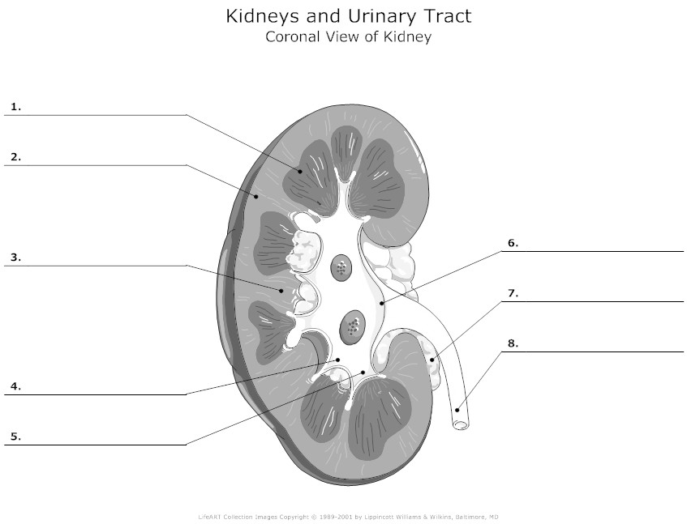

KIDNEY AND URINARY TRACT
- Renal pyramid
- Cortex
- Medulla
- Minor calyx
- Major calyx
- Renal pelvis
- ____ don't worry about
- Ureter
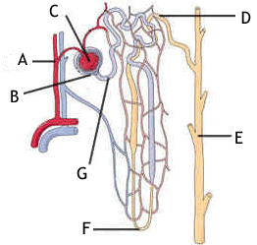

- –
- Bowman’s Capsule
- Glomerulus
- Distal Tubule
- Collecting Duct
- Loop of Henle
- Proximal tubule

REMINDER YOURS IS LABELED DIFFERENTLY ON THE DIAGRAM ABOVE. (Afferent and efferent arterioles are not labeled.

NEPHRON-according to your study guide
- Afferent arteriole
- Glomerulus
- Efferent arteriole
- Distal tubule
- Collecting Duct
- Loop of Henle
- Proximal tubule
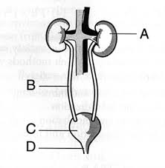
- Bowman’s capsule

Pathway of Urine
- Kidney
- Ureter
- Bladder
- Urethra

